**ASSIGNMENT-24.4:**

A table named titanic is created and the data is loaded into the table. The columns of the titanic table are described below.

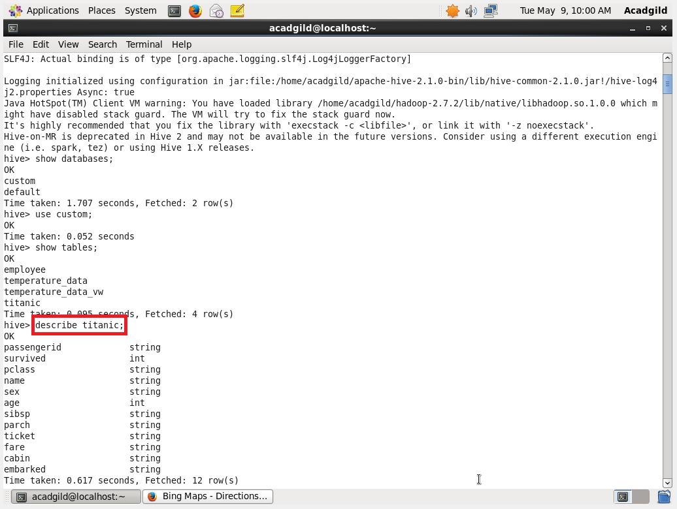

**QUESTION 1** : Write a hive query find the average age of male and female persons died in the titanic tragedy

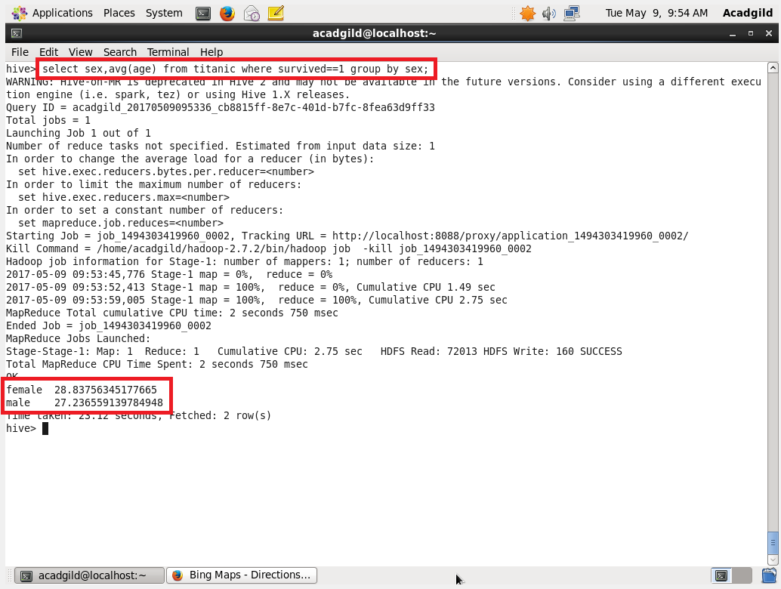

**QUESTION 2 :** Write a hive query to find the number of people died and survived in each class.

